1. 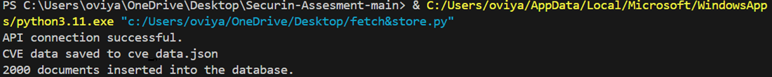Consume the CVE information from the CVE API for all the CVE's and store it in a Database of your choice.

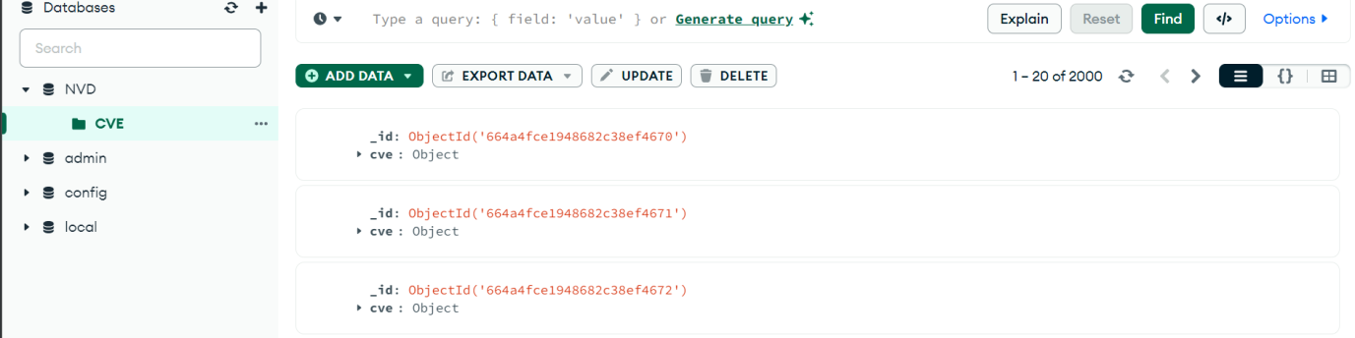

1. Apply data cleansing & de-duplication, ensure data quality wherever applicable

3.When the index.html file is opened , its displays all the cve table entries as in the format indicated in the problem statement

OUTPUT:

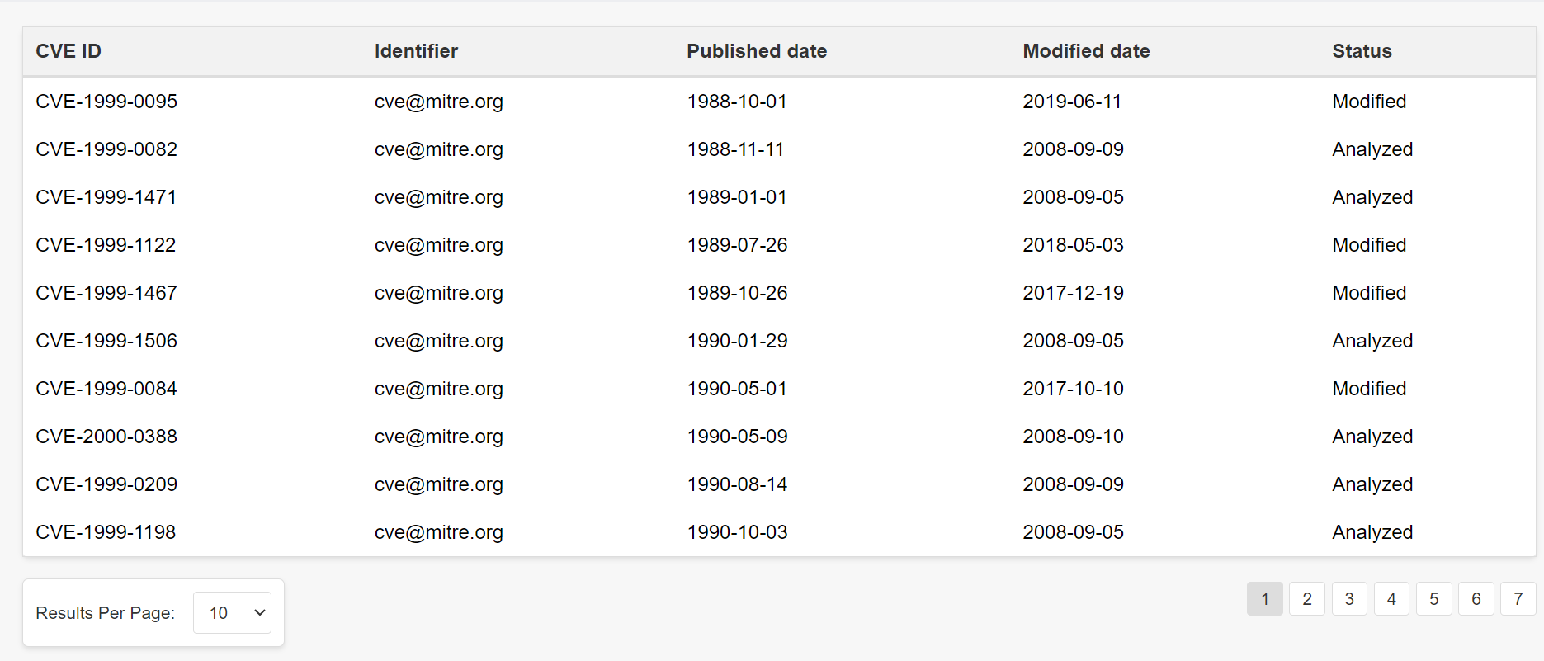

4.When any of the Data under CVE ID is clicked , it navigates to the corresponding vulnerability details of that specific data

OUTPUT :

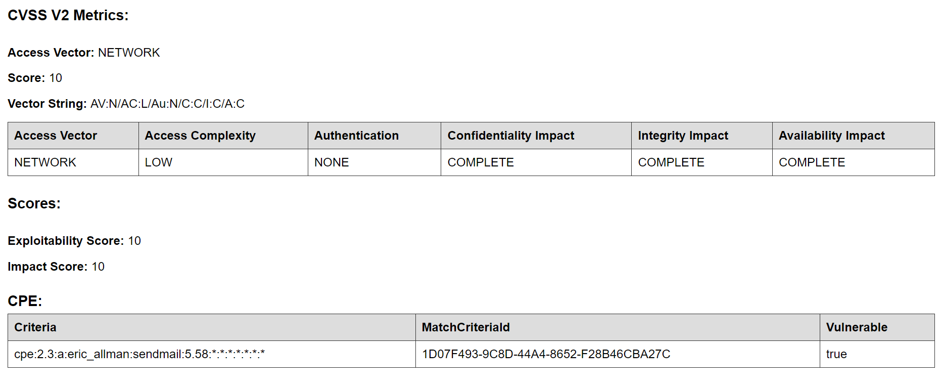

APIs for filtering CVE details

1. **CVE ID**

* + To retrieve information on a single CVE or a collection of CVEs, you can use the National Vulnerability Database (NVD) API.
  + The base URL for retrieving CVE information is: [NVD CVE API](https://services.nvd.nist.gov/rest/json/cves/2.0)
  + You can pass the CVE ID as a query parameter to this API to get details about a specific vulnerability.

1. **CVE ID’s Belonging to a Specific Year**
   * You can filter CVEs by publication year using the NVD API. For example, to get all CVEs published in 2022, you can add a query parameter like &pubStartDate=2022-01-01T00:00:00:000 UTC-05:00 to the API URL.
2. **CVE Score (CVSS Base Score)**
   * The CVSS (Common Vulnerability Scoring System) base score is available in the NVD API response. You can filter CVEs based on their CVSS scores (e.g., low, medium, high, critical).
   * Use the cvss query parameter to filter by CVSS score (e.g., &cvss=high).
3. **Last Modified in N Days**
   * To filter CVEs based on their last modification date, you can use the NVD API with the lastModifiedDate query parameter.
   * For example, to get CVEs modified in the last 7 days, you can add &lastModifiedDate=7 to the API URL.